NWEA Practice Jeopardy Game
Question/Answer Sheet

To play go here: jeopardylabs.com/play/nwea-practice4.
If you ever want to edit this template, go to jeopardylabs.com/edit/nwea-practice4

If you get a question wrong, write it down on a piece of paper and try to find out how they got the correct answer. Don’t forget to show your work.
Use these to check your answers or to get the question when you need to. Please don’t look ahead to other answers.

Question | Picture or Answer
Fractions for 200 | 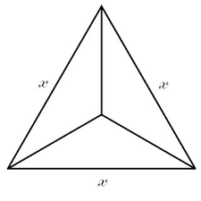
Fractions for 300 | or
Telling Time for 100 | Question: 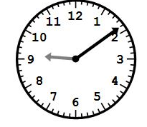
Telling Time for 200 | Question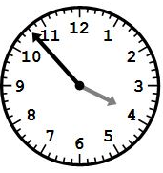
Geometry and measurement  For 100 | 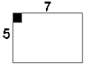 5 + 7 + 5 + 7 = 24
Geometry and Measurement for 400 | 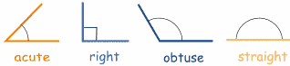
Geometry and measurement for 500 | 