A.
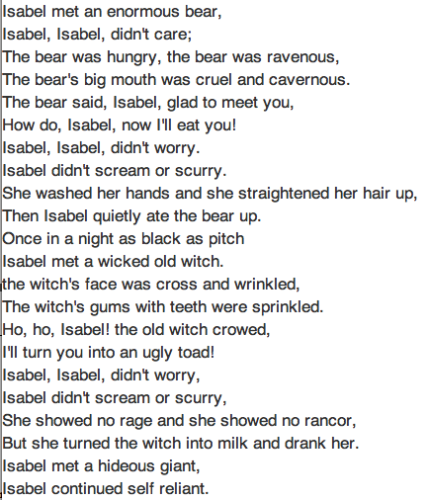
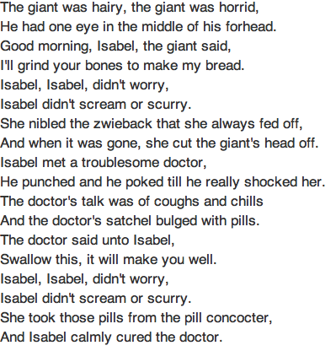

B. Eletelephony
Laura Elizabeth Richards
Once there was an elephant,
Who tried to use the telephant—
No! No! I mean an elephone
Who tried to use the telephone—
(Dear me! I am not certain quite
That even now I’ve got it right.)
Howe’er it was, he got his trunk
Entangled in the telephunk;
The more he tried to get it free,
The louder buzzed the telephee—
(I fear I’d better drop the song
Of elephop and telephong!)

C.
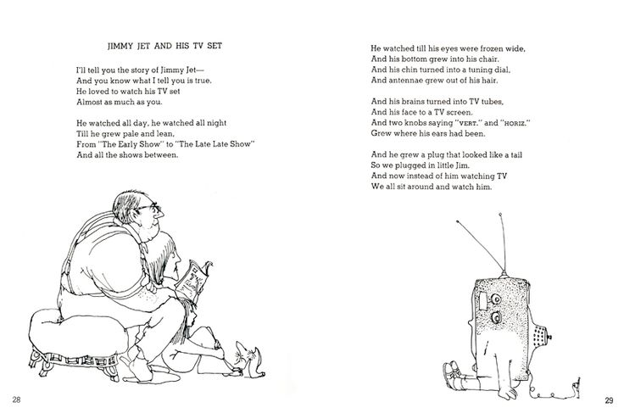

D. Father William by Lewis Carroll

OU are old, Father William," the young man said,
"And your hair has become very white;
And yet you incessantly stand on your head--
Do you think, at your age, it is right?"

"In my youth," Father William replied to his son,
"I feared it might injure the brain;
But, now that I'm perfectly sure I have none,
Why, I do it again and again."

"You are old," said the youth, "as I mentioned before,
And have grown most uncommonly fat;
Yet you turned a back-somersault in at the door--
Pray, what is the reason of that?"

"In my youth," said the sage, as he shook his gray locks,
"I kept all my limbs very supple
By the use of this ointment -- one shilling the box --
Allow me to sell you a couple?"

"You are old," said the youth, "and your jaws are too weak
For anything tougher than suet;
Yet you finished the goose, with the bones and the beak--
Pray, how did you manage to do it?"

"In my youth," said his father, "I took to the law,
And argued each case with my wife;
And the muscular strength which it gave to my jaw
Has lasted the rest of my life."

"You are old," said the youth, "one would hardly suppose
That your eye was as steady as ever;
Yet you balanced an eel on the end of your nose--
What made you so awfully clever?"

"I have answered three questions, and that is enough,"
Said his father; "don't give yourself airs!
Do you think I can listen all day to such stuff?
Be off, or I'll kick you down-stairs!"

F.

Dream Variations
Langston Hughes, 1902 - 1967
To fling my arms wide
In some place of the sun,
To whirl and to dance
Till the white day is done.
Then rest at cool evening
Beneath a tall tree
While night comes on gently,
Dark like me—
That is my dream!

To fling my arms wide
In the face of the sun,
Dance! Whirl! Whirl!
Till the quick day is done.
Rest at pale evening . . .
A tall, slim tree . . .
Night coming tenderly
Black like me.

G.

By Myself
When I’m by myself
And I close my eyes
I’m a twin
I’m a dimple in a chin
I’m a room full of toys
I’m a squeaky noise
I’m a gospel song
I’m a gong
I’m a leaf turning red
I’m a loaf of brown bread
I’m a whatever I want to be
An anything I care to be
And when I open my eyes
What I care to be
Is me.
Eloise Greenfield

H.

Trees by Joyce Kilmer
I THINK that I shall never see
A poem lovely as a tree.
A tree whose hungry mouth is prest
Against the sweet earth's flowing breast;
A tree that looks at God all day, | 5
And lifts her leafy arms to pray;
A tree that may in summer wear
A nest of robins in her hair;
Upon whose bosom snow has lain;
Who intimately lives with rain. | 10
Poems are made by fools like me,
But only God can make a tree

I.

Catch a Little Rhyme
By Eve Merriam
Once upon a time
I caught a little rhyme

I set it on the floor
but it ran right out the door

I chased it on my bicycle
but it melted to an icicle

I scooped it up in my hat
but it turned into a cat

I caught it by the tail
but it stretched into a whale

I followed it in a boat
but it changed into a goat

When I fed it tin and paper
it became a tall skyscraper

Then it grew into a kite
and flew far out of sight ...

K.
First Thanksgiving Of All
by Nancy Byrd Turner
Peace and Mercy and Jonathan,
And Patience (very small),
Stood by the table giving thanks
The first Thanksgiving of all.
There was very little for them to eat,
Nothing special and nothing sweet;
Only bread and a little broth,
And a bit of fruit (and no tablecloth):
But Peace and Mercy and Jonathan
And Patience, in a row,
Stood up and asked a blessing on
Thanksgiving long ago.
Thankful they were their ship had come
Safely across the sea;
Thankful they were for hearth and home,
And kin and company;
They were glad of broth to go with their bread,
Glad their apples were round and red,
Glad of mayflowers they would bring
Out of the woods again next spring.
So Peace and Mercy and Jonathan,
And Patience (very small),
Stood up gratefully giving thanks
The first Thanksgiving of all.

